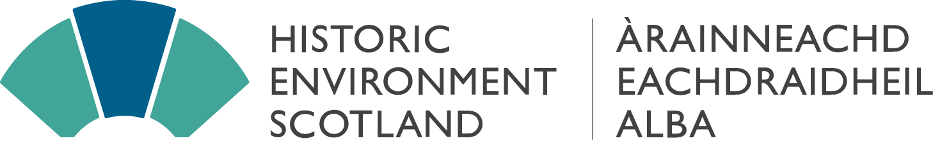

Business & Regulatory Impact Assessment – Exemption statement

A Business and Regulatory Impact Assessment (BRIA) is used to analyse the cost and benefits to businesses and the third sector of any proposed legislation or regulation, with the goal of using evidence to identify the proposal that best achieves policy objectives while minimising costs and burdens as much as possible.
HES is a charitable Non-Departmental Public Body (NDPB) whose statutory functions are set out in the Historic Environment Scotland Act 2014. As such, the Scottish Government states that HES is “responsible for their own BRIA quality monitoring, making sure they have consulted with economists, analysts, businesses and third sector organisations as appropriate”. There is no statutory consultation authority for the BRIA, so the decision for whether a BRIA is required sits with the Chief Executive.
HES has concluded that a BRIA is not required for the 2022 Corporate Plan Refresh based on the following rationale:
- The 2019 Corporate Plan was developed through an engagement process which included extensive consultation with Local Authorities, organisations, businesses and public forums. That process concluded that none of the actions and outcomes in the Corporate Plan would have significantly different financial or legal effects on organisations and businesses.
- Given that COVID disrupted 2 years of delivery of the existing 3-year Corporate Plan, a light refresh is being conducted for 2021/22 retaining the same headline themes and outcomes. The business and organisational conclusions from the 2019 consultation are therefore assumed to be unchanged. A full engagement process is planned for the new Corporate Plan starting in 2023, with the need for a new partial (and potentially full) BRIA being re-visited during 2023.
- The previous Full BRIA process around the HES Corporate Plan did not raise any substantial concerns from businesses or organisations, and its findings are still considered to be applicable.
- Following Scottish Government guidance, the need for a BRIA was considered with the in-house economist, analysts and legal team together with insights on businesses and partners gathered through the on-going delivery of HES’s operations. Following this process, HES has concluded “no” for each of the Scottish Government’s key questions which define the need for a BRIA:
Does the proposal: impose additional, or reduce existing, costs on relevant businesses or third sector organisations? | No
impose additional costs on public sector organisations that deliver services? | No
involve a transfer of costs or benefits from one group to another, even where it does not change overall net costs or benefits? | No
HES is proposing a tailored approach with local partners, understanding the needs and circumstances in local economies, rather than imposing new national standards on businesses and partners. The previous Full BRIA concluded that businesses and partners were supportive of the proposed partnership approach and recognition of local circumstances, also noting that the Planning was at a high level with no clear change in engagement or relationships at a practical level.
HES’s direct relationships with businesses are governed by HES’s new Procurement Strategy which follows the Scottish Government’s statutory process. HES is therefore not adding any new practical regulatory or re-distributive burden through delivery of the Corporate Plan that has not already been approved by the Scottish Government.

Business and Regulatory Impact Assessments (BRIA): guidance - gov.scot (www.gov.scot)
Corporate Plan 2016-19 Final Business and Regulatory Impact Assessment (historicenvironment.scot)

